|  |  |
| --- | --- |
| **STUDENT CARD** |  |

Please complete this form in CAPITAL LETTERS and attach one recent passport size photograph with a paper clip.

**Do not staple your photograph to the form.**

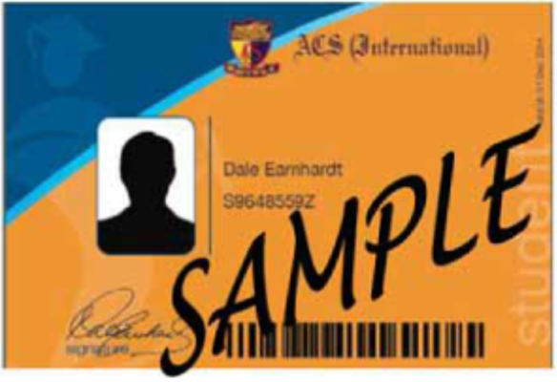

|  |  |
| --- | --- |
| **STUDENT DETAILS** | |
| Name (as in Passport/NRIC) *(Please underline surname)* | Preferred Name |
| NRIC / FIN | House (for Current Student) |
| Level *(Please tick ONE box only)* | |
| Year 1B  Year 1  Year 2  PRE IGCSE  Year 3  Year 4  Pre IB  Foundation IB  Year 5  Year 6 | |
| Date of Application | |

*Updated in August 2018*